Lab No. 09

Part I: Data Loading & Exploration

1. Import Libraries
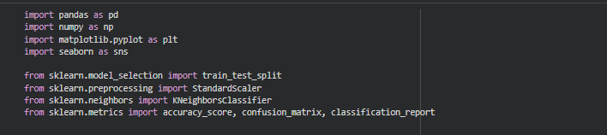

2. Load Dataset
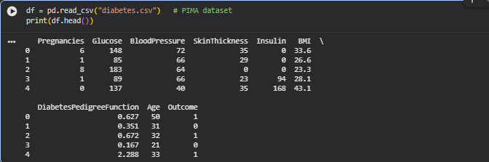

3. Identify Independent & Dependent Variables
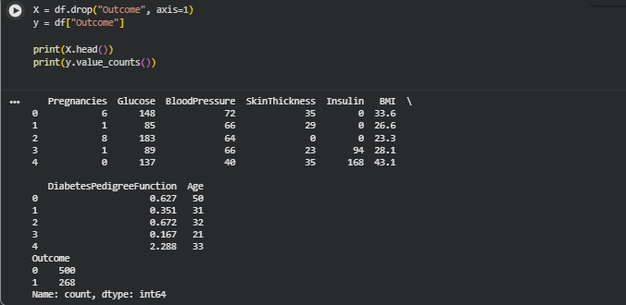

4. EDA (Exploratory Data Analysis)
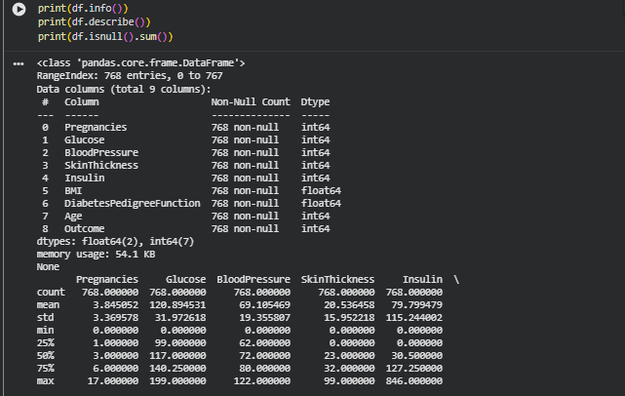
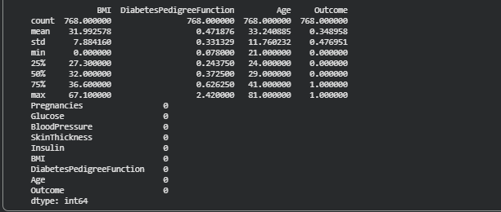
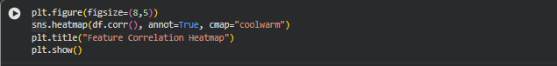
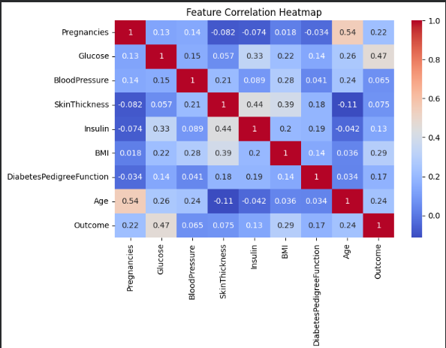

Part II: KNN Model (Without Scaling)

5. Train-Test Split

6. Build KNN Model
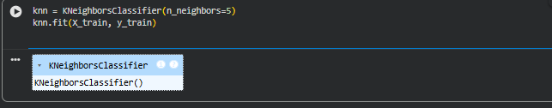

7. Predictions

8. Evaluation
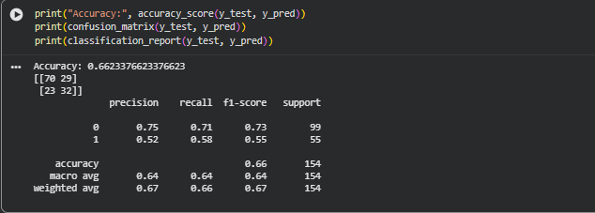

Part III: Standardization + KNN Model

9. Feature Scaling

10. Train-Test Split (Scaled Data)
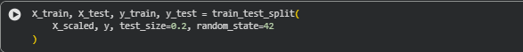

11. Train KNN on Scaled Data
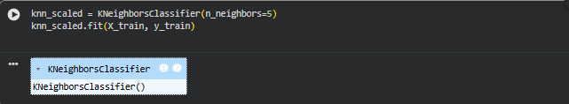

12. Predictions & Evaluation
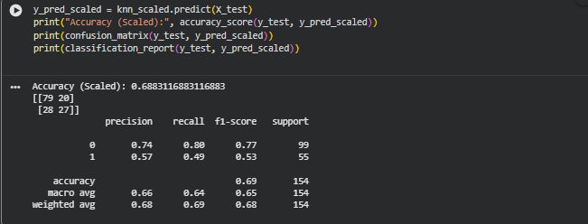Part IV: Hyperparameter Tuning (Best K Selection)

13. Find Best K Programmatically
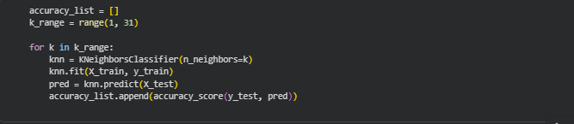14. Plot K vs Accuracy Graph
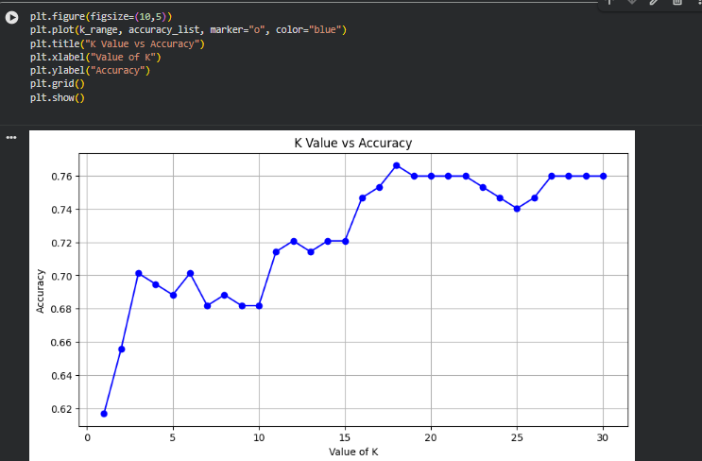

15. Best K Value
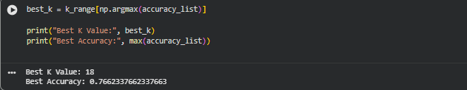

16. Final Optimized Model
